**Python**

Use two asterisks and a question mark like np.*load*? To get an overview of all functions that contain that word:

If you have a = [1, 2, 3] and then write b = a, then you are not *copying* a to b, but *creating a second reference* to [1, 2, 3]. Like here:

Use isinstance(a, int) to check whether an object is of a specific object type:

Use iter() to check whether an object is iterable (e.g. you can perform a loop on it):

**Importing parts of a module**

**Binary operations**

**Note that == is not the same as is**

Take a = 2, b = a, and c = list(a). Both a == b and a == c will return True, because all of the objects are equal to value 2. But only a is b will return True, because b refers to a and is not a *separate copy* like c. The list() function always creates a separate copy (a new list).

**Python scalar types (data types)**

None, str, bytes, float, bool, int

**Working with dates**

Use from datetime to import types like datetime, date or time.

Use datetime() to create a date with time:

Use date() to return date and time() to return time:

The strftime method formats a datetime as a string:

**Replace parts of dates with 0, e.g. minutes and/or seconds:**

**for loops with continue and break**

Use continue to continue the iteration (skip the value)

To stop the iteration use break:

The break keyword only terminates the innermost for loop; any outer for loops will continue to run:

A while loop:

Use pass in a loop in blocks where no action is to be taken:

**Built-In Data Structures, Functions, and Files**

Tuple, list, and dictionary are some of the most frequently used sequence types.

**Tuples**

If you have a tuple like values = 1, 2, 3, 4, 5 and want to assign only the first two values a name and other values are not important you can make use of *rest or *_. Name after asterisk can be rest or _ or anything else.

Count the number of occurrences in a tuple using a.count():

**Lists**

The list() function can be used to materialize an iterator or a generator:

**List concatenation** can be done using + or .extend(). Using .extend() is preferable due to computational efficiency.

**Slicing in Python example:**

Use [::2] to select every second value or [::-1] to inverse a list:

**Dictionary**

Use .pop to delete a value in a dictionary and return it as a variable:

Use functions .keys(), .values(), and .items() to iterate (or select) over keys, values, and both keys & values in a dictionary:

Update a dictionary using .update():

Iterating over a dictionary (create a dictionary from two lists):

Create a dictionary from a dict():

**To sort a list of values by e.g. its first letter:**

Option 1: Option 2 (preferred):

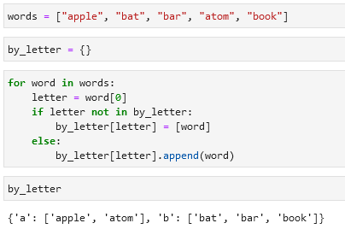

Or option 3 (preferred):

**Valid keys and values in dictionaries**

* Values can be any Python object.
* Keys have to be immutable objects like scalar types (int, float, string) or tuples (all the objects in the tuple need to be immutable).

To check whether a value can be used as a key use hash() (check for hashability):

**Set**

A set is an unordered collection of unique elements.

Two ways to create a set:

Set operations:

**Sequence functions**

**Enumerate**

**zip**

zip “pairs” up the elements of a number of lists, tuples, or other sequences to create a list of tuples:

The number of elements it produces is determined by the shortest sequence:

A common use of zip() is simultaneously iterating over multiple sequences:

**reversed**

Iterates over the elements of a sequence in reverse order:

**List, Set, and Dictionary Comprehensions**



=

**Example of a list comprehension:**

**Dictionary comprehension:**

**Set comprehension:**



Alternative to set comprehension is the map() function:

**Dictionary comprehension:**

**Nested list comprehension:**

Example 1:

Example 2:

**Functions**

Example of a function:

**Cleaning text in a list:**

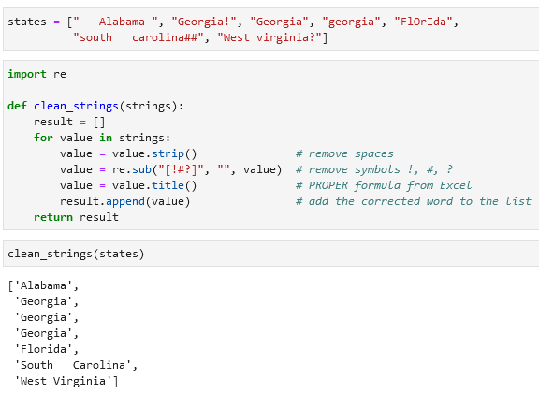re, .strip(), .sub(), .title()

**Lambda functions**

**Generators**

Generator example:

yield

**Generator expressions**

**intertools module**

Example with a intertools.groupby() function:

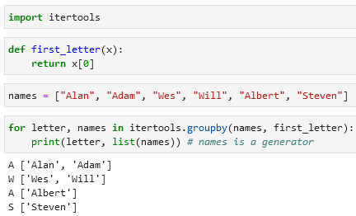

Some useful functions from the itertools module:

chain(*iterables), combinations(iterable, k), permutations(iterable, k), groupby(iterable[,keyfunc]), product(*iterables, repeat = 1)

**Files and the operating system**

Open a file:

Two possibilities to close a file:

**Numpy**

Functions for creating an NumPy array:

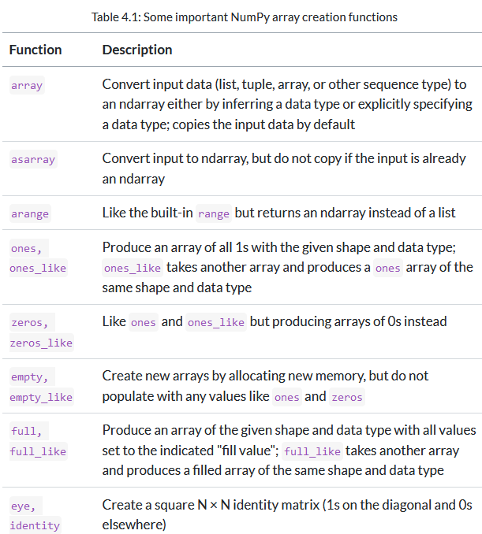

np.array, np.asarray, np.arange, np.ones, np.ones_like, np.zeros, np.zeros_like, np.empty, np.empty_like, np.full, np.full_like, np.eye, np.identity

If not specified, the data type will be float64 (in many cases).

**NumPy slicing**

**Boolean indexing**

Imagine every value in the *names* array is a representative of the *data* array. So value in *names* with *index 0* is a value in *data* with *index 0* and so on. If we want to select all of the values in *data* that correspond to *“Bob”* in *names* you can do it this way:

Note that both arrays should be of the same lengths (e.g. in this example both arrays have 7 values).

If you want to select everything but except a specific value you can use != or ~():

To select AND / OR use & for AND and | for OR:

**Fancy indexing**

To select specific rows in a particular order use a list:

Using two lists for index will return values that are found using these “coordinates”. In the example below 4 is returned after coordinate 1, 0 and 23 is returned after coordinate 5 and 3 etc.

Another example:

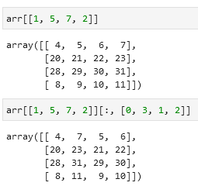

**Transposing arrays**

Calculating inner matrix product using np.dot():

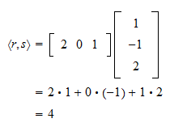

@ is an alternative to np.dot():

Also an option df.swapaxes(0, 1):

**Pseudorandom number generation**

Use the np.random.standard_normal() function and module (random) to generate pseudorandom numbers:

**Universal functions**

Use np.modf(df) to return the fraction and the number separately:

**Conditional logic as array operations**

You can make a loop to select values from *xarr* when a value is True in *cond* and select values from *yarr* when it is False. A more efficient alternative is the np.where(condition, df1, df2) function:

Or you can replace all positive values with a certain number (in the example below with 2) and all negative values with a different number (below -2):

**Basic array statistical methods**

sum, mean, std, var, min, max, argmin, argmax, cumsum, cumprod

Examples like cumsum():

**Unique and other set logic**

Remove duplicates and sort them using np.unique(df):

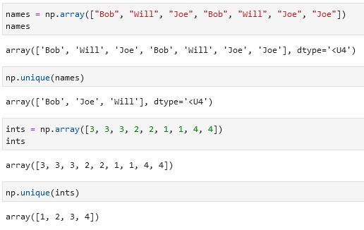

Python alternative (which is more inefficient):

Check whether some values are in an array using np.in1d():

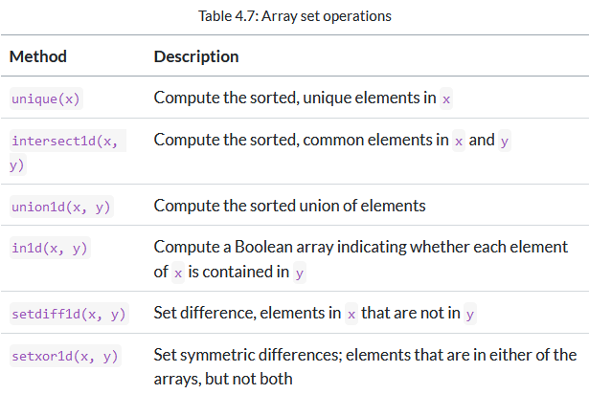

Unique, intersect1d, union1d, in1d, setdiff1d, setxor1d

**Saving and loading files in NumPy**

Use np.save(), np.load(), np.savez(), np.savez_compressed() to save and load files.

Same with comments:

**Linear algebra functions**

Diag, dot, trace, det, eig, inv, pinv, qr, svd, solve, lstsq

**Pandas**

Transform a DataFrame into a NumPy array using df.to_numpy():

**Some index methods and properties**

**The .reindex() function will perform a join of values present in your Series based on the current and the new indexes:**

Example with fill_value:

df1: 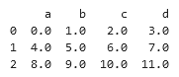 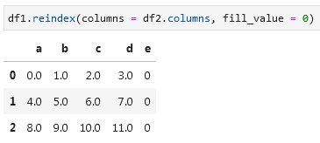

**Create a DataFrame using np.arange() and .reshape():**

**The .reindex() function arguments:**

**If you want to change the position of index/columns of a DataFrame you can use df.loc:**

**Difference between df.loc and df.iloc:** df.iloc selects on the index *(0, 1, 2, 3 etc.)* while df.loc selects numerical values in the index like *1, 3, 2* will look for rows with these indexes:

**Indexing with DataFrame**

**Adding two DataFrames**

Use df1.add(df2, fill_value = 0) to add one DataFrame to the second:

**Flexible arithmetic methods between two DataFrames:**

**Function application and mapping**

Apply format to a DataFrame using frame.applymap():

**Sorting and ranking**

To sort an index use df.sort_index():

To sort a Series by its values use obj.sort_values():

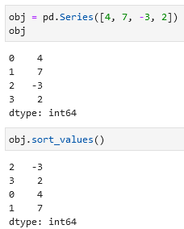

To sort a DataFrame pass a column name(s) which should be used to sort:

**Tie-breaking methods with rank:**

**Summarizing and computing descriptive statistics**

Options for reduction methods:

Return the index of the maximum/minimum value using df.indxmax() or df.indxmin():

Cumulative sum by rows using df.cumsum():

**A full list of summary statistics and related methods:**

**Unique values, value counts, and membership methods**

**Data loading, storage, and file formats**

Text and binary data loading functions in pandas:

Import a csv using pd.read_csv() with different settings:

Some pd.read_csv() function arguments:

**Reading Excel files**

Use pd.read_excel() or pd.ExcelFile() to open (read) Excel files:

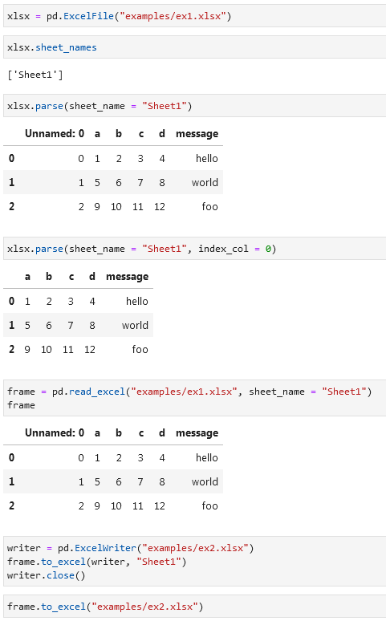

**Reading SQL**

**Data cleaning and preparation**

**Handling missing data**

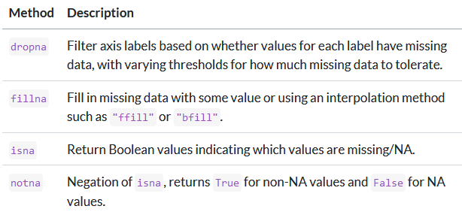dropna, fillna, isna, notna

Examples with df.fillna():

Function arguments of df.fillna():

Removing duplicates using df.duplicated() and df.drop_duplicates():

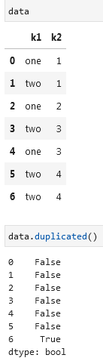

**Perform a LEFT JOIN on a column (add a column, merge two tables) using .map():**

**Replace values using df.replace():**

**Renaming axis indexes**

**Binning, grouping, categorization**

You can bin using pd.cut(df, bins) and then get a GROUP BY using df.value_counts():

pd.qcut(df, bin).value_counts():

**Working with outliers**

If you want to get values that are more than a certain positive number and less than a certain negative number you can use .abs() > 3:

**To select all rows having a value exceeding 3 or –3, you can use the any method:**

Replace all values above 3 and below -3 with a 3/-3:

Example of np.sign() (it returns 1 for positive values, -1 for negative, and 0 for 0):

**To randomly reorder columns/rows in a DataFrame use np.random.permutation():**

Permutation of columns:

Select a certain number of random rows using df.sample(n = ):

If you want to select more random rows than there are in a Series/DataFrame, you can add replace = True, it will allow returning duplicate rows:

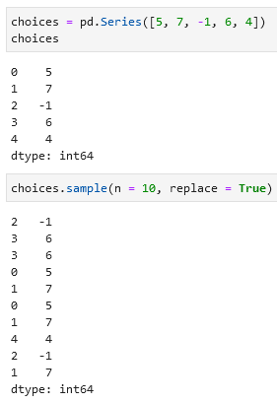

**Computing indicator/dummy variables**

You have a column named *City* with 3 variables: *London, Paris, Berlin.* You can unpivot this column into columns like *London?, Paris?, Berlin?* where in each column a 0 will mean *No* and 1 will mean *Yes.* To do so use pd.get_dummies(df[“column_name”]):

Merge these column back with the rest of the table:

Unpivoting using str.get_dummies():

Combining pd.get_dummies() and pd.cut():

**String manipulation (text manipulation/edition)**

Some examples with .split(), .index(), .find(), .count(), .replace():

**Regular expressions (regexs) methods**

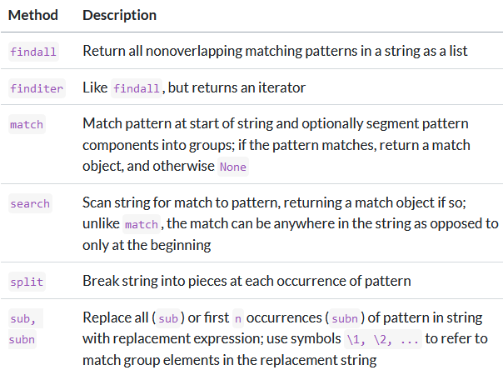

**String functions in pandas**

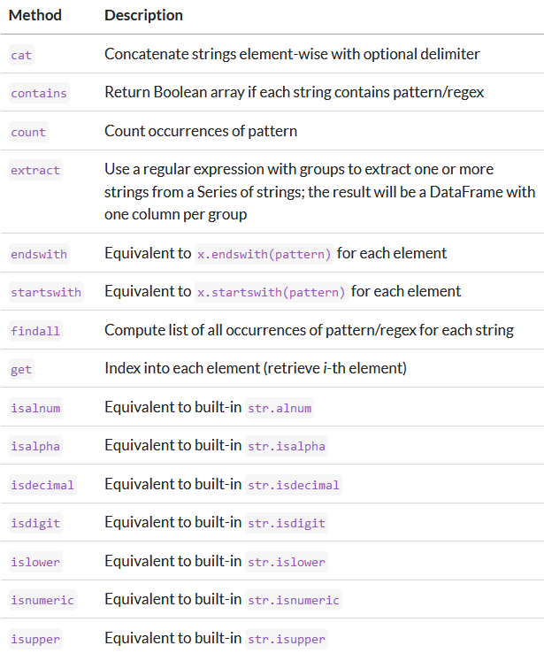

**Categorical methods (save memory and computation time)**

**Data wrangling: JOIN, combine, and reshape**

To index this Series:

You can also unpivot a table using df.unstack() or pivot a table using df.stack():

Hierarchical indexing for DataFrames:

Check how many levels does an index have with df.index.nlevels:

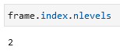

Creating a MultiIndex:

To rearrange an index use df.swaplevel(index1, index2):

To sort an index use df.sort_index() (with df.sort_index() or df.sort_index(level = 0) performance is much better):

Take a column/two columns and create an index out of them using df.set_index(column1, column2). Columns will be removed from the DataFrame, but you can keep them by adding drop = False:

To move the hierarchical index levels into the columns use df.reset_index():

**Combining and merging datasets**

Merge two DataFrames using df.merge(df1, df2, on = “column_name”):

Perform an inner-join:

Perform a full-join / outer join:

Example of a left-join:

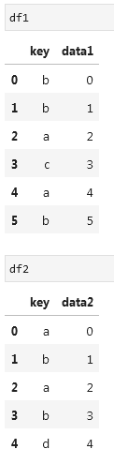

Types of joins in the how = argument:

Join on two columns:

When you're joining columns on columns, the indexes on the passed DataFrame objects are discarded. If you need to preserve the index values, you can use reset_index to append the index to the columns.

df.merge() function arguments:

To merge on index make use of right_index = True or left_index = True:

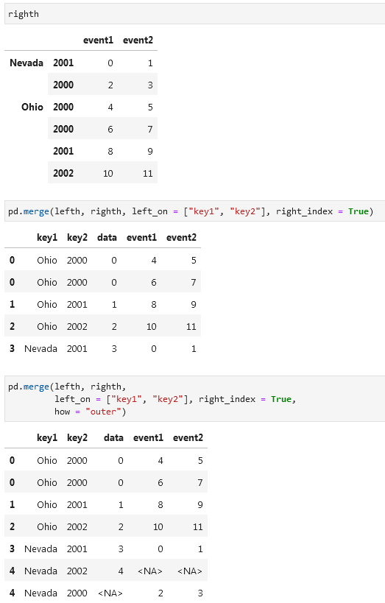

You can also use df1.join(df2, how =) to perform a join:

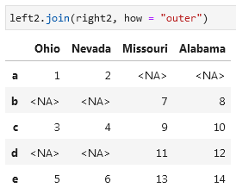 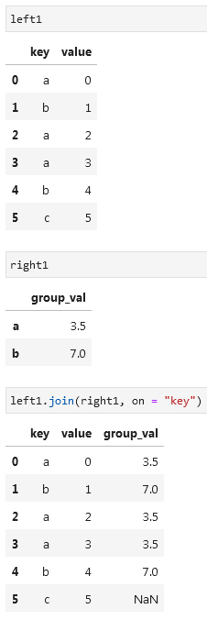

Merge several DataFrames:

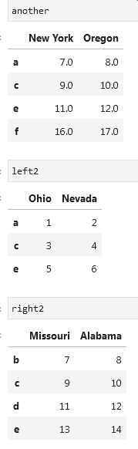

**Appending tables (concatenation)**

You can append tables using np.concatenate:

Use pd.concat([df1, df2, df3]) to append tables:

Create hierarchical index using keys:

If you combine tables along the axis = 1 (horizontally and not vertically) keys will be the names of the columns:

Creating a hierarchical index in a DataFrame:

If you want to ignore the index in both tables you can add ignore_index = True:

pd.concat function arguments:

If you have two tables and want to select data from the first table and only select values from the second table when the values in the first table are blank, then you can use np.where(pd.(isna(table1), table2, table1). Also see df1.combine_first(df2):

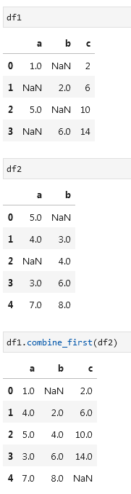

**Reshaping and pivoting**

Use df.stack() or df.unstack() to pivot/unpivot. If you want to select a specific index

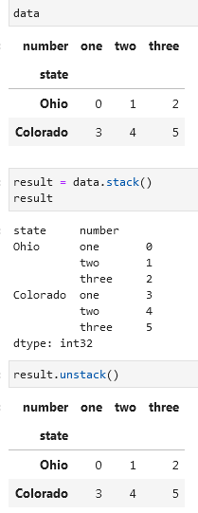

Add blank values with stacking and unstacking:

Indicate which level (index) to use for stacking/unstacking with level =:

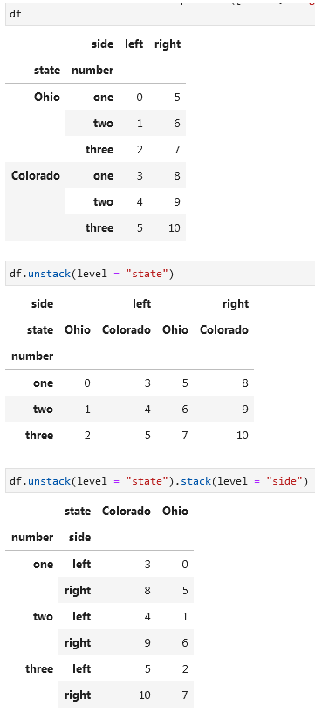

Converting columns with year and quarter information into a day-month-year index (pop() means select column and drop it from the DataFrame) using pd.PeriodIndex() and df.to_timestamp(“D”):

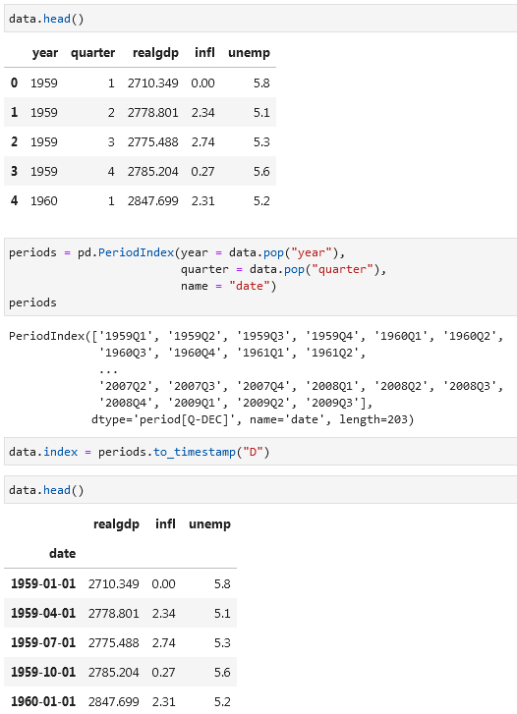

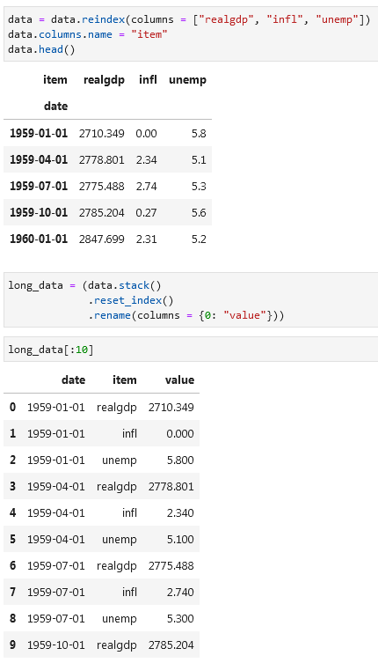

To unpivot other columns you can use pd.melt(df, id_vars = “column_that_will_not_be_unpivoted”):

To return the table back to its original form:

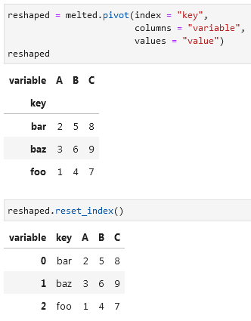

You can filter columns that you want to use in the unpivoting process using value_vars. Here column C was dropped:

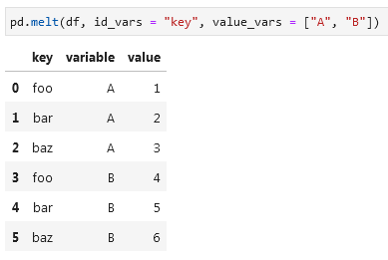

You can also drop your group identifier:

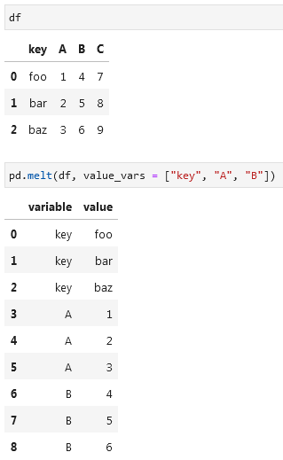

**Plotting and visualization**

matplotlib.pyplot.subplots options:

**Annotations and drawing on a subplot**

**Saving plots to file**

**Matplotlib configuration (font, size)**

For more extensive customization and to see a list of all the options, matplotlib comes with a configuration file matplotlibrc in the matplotlib/mpl-data directory. If you customize this file and place it in your home directory titled .matplotlibrc, it will be loaded each time you use matplotlib.

**Plotting with pandas**

If you want to get a pivot table between two variables you can use pd.crosstab():

**To normalize a table (so that values in a column are equal to 100% / 1):**

**Data aggregation and group operations**

Hadley Wickham coined the term *split-apply-combine* for describing group operations.

Using the example below you group your data first according to its indexes, then you sum the values inside these groups, and finally you combine the results of these groups.

GROUP BY examples with df[“col_with_values”].groupby(df[“group_on_col”]):

To group on two columns:

You can also unpivot this result:

You can also use external indexes to perform a GROUP BY, like in the example below:

A useful GroupBy method is .size() (like a pivot that returns the number of values in each group/category):

Alternative to .size() can be .count():

Any missing values are excluded from the result by default. This can be disabled using the dropna = False feature:

**Selecting a column/columns**

**Grouping with dictionaries and series**

You can pass an index column that will be used for grouping as a separate dictionary/series:

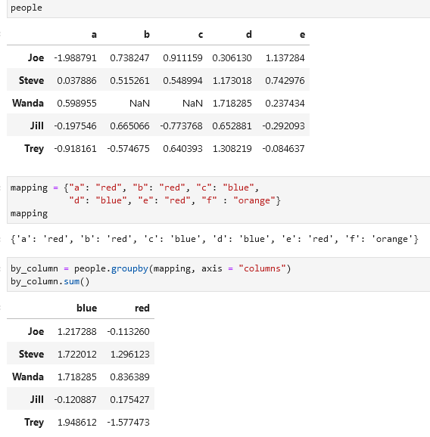

**Grouping with functions**

**Group by index levels**

**Data aggregation**

Optimized groupby methods:

Returning two smallest values from a groupby using .nsmallest(2):

To use your own aggregations write .agg(function):

Methods like .describe() can also be used on grouped objects:

**Aggregating on multiple columns:**

If you want to return custom names make use of tuples with column names first and functions second:

Example with applying 3 functions on two selected columns:

Another example:

**Applying different functions on different columns is possible using dictionary. Two examples:**

To return aggregated data without row indexes use as_index = False (better) or .reset_index() on the result:

You can return the top X rows per each category using your custom function and a groupby(“column”).apply(function):

Examples with .describe():

If you don’t want to create an index-column with the grouped value you can type group_keys = False:

**Quantile and bucket analysis**

Use pd.cut(df, number_of_buckets) to put your values into buckets:

These buckets can be now used for further analysis:

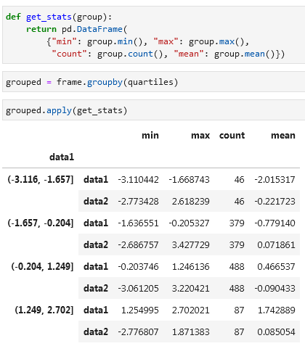

Alternatively using .agg() instead of .apply(function):

Using the pd.qcut() (equal-size buckets based on sample quantiles; pass labels = False to obtain just the quartile indices instead of intervals) formula instead of pd.cut() (equal-length buckets):

**Filling Missing Values with Group-Specific Values**

You can use s.fillna(s.mean()) to fill N/A values with a mean of a Series:

Another example with filling group-specific values:

Alternatively you can use a dictionary:

**Random Sampling and Permutation**

**Group Weighted Average and Correlation**

Next to .describe() you can use df.info() to get an overview of a DataFrame:

